# Grade 4 ELA CCGPS Frameworks - Unit 1

## 

## Unit Title Discoveries and Beginnings

## Overview of the unit

Designed to complement science and social studies frameworks and standards, the English Language Arts CCGPS Frameworks are a resource for all teachers to use. The theme, Discoveries and Beginnings, can relate to Native Americans and explorers in the social studies curriculum. In science, the unit can reflect or assess knowledge of ecosystems and ecology. In addition, the lessons lend themselves well to setting rituals and routines at the beginning of the school year. This unit is separated into reading lessons and language arts lessons with two columns used throughout to denote the different lessons. Teachers who are departmentalized will want to collaborate to ensure that they are using common literature and assessments. Teachers who are self-contained should understand that the lessons can be combined into a reading/language arts block. The Reading and ELA lessons do not have to be taught in tandem.

The unit has formative and summative assessments throughout that can be adapted or modified to meet individual teacher’s needs. There is a summative performance-based portfolio assessment designed to be used as a culminating activity. The culminating activity can be modified to suit individual classroom needs. Although there is a suggested text list at the end of the unit, the literature selection is ultimately left up to the teacher.

In this unit, some of the **Big Ideas** and **Enduring Understandings** that students will learn will be:

* Details and examples are useful in explaining text.
* Understanding inferences made in a text is necessary in explaining the text. Identifying the main idea of a text enables comprehension.
* Key details in text are essential in understanding key concepts.
* Being able to summarize text is essential for deep comprehension, application, and analysis of a text.
* Effective readers are able to give specific details/information from the text to explain an event, procedure, idea or concept.
* Good readers integrate information from multiple texts to write or speak about the subject knowledgeably.
* Good readers use details in the text to draw inferences.
* Collaborative discussions require participants to initiate and participate in various roles.
* Good readers/speakers clearly express appropriate, relevant ideas and details about shared topics, stories, or experiences.
* It is important to differentiate between situations that require formal English and those where informal English is more appropriate.
* Effective writers create more detailed writing by providing support from their informed and reasoned point of views.
* It is important to clearly convey information in all types of writing.

## 

## 

## 

|  |  |
| --- | --- |
| **Reading Lessons**  **Lesson 1**  **Standards:**  ELACC4RL1: Refer to details and examples in a text when explaining what the text says explicitly and when drawing inferences from the text.  ELACC4RI4: Determine the meaning of general academic language and domain-specific words or phrases in a text relevant to a grade 4 topic or subject area.  ELACC4SL1: Engage effectively in a range of collaborative discussions (one-on-one, in groups, and teacher-led) with diverse partners on *grade 4 topics and texts*, building on others’ ideas and expressing their own clearly.  **Learning Target**   * I can refer to details and examples in a text. * I can understand the meaning of words in a text. * I can participate in discussions to express my own ideas or build on others’ ideas.   **Instruction**  *Mini-Lesson(s)*:   * Introduce the reading block procedures. Begin “Reader’s Notebook” or “Reader’s Response Journal”. This notebook can be used to allow the students to do any (or all) of the following: * Record books they've read * Keep track of the genres being read * List books they would like to read in the future * Keep track of partner reading, discussions, and meeting times * Respond to their reading * Prepare for book talks * Model using details and examples from a text to explain understanding of vocabulary, comprehension of story elements and/or information, and inferring information through explicit examples or information from the text. * Ask students to write a simple retell of any story. This may be part of an anchor text being read (whole-class) or a book or story (of the student’s choosing) which they have read during the day or week. After they retell the basic content of the story, ask the students to identify one (or more) of the following three connections: **1) Text to Self** - the student identifies **commonalities between the story and events in their own lives**; **2) Text to Text** - the student identifies **commonalities between this story and another story they have read**; or **3) Text to World -** the student **identifies commonalities between this story and events they know of in the world.** * After modeling examples of detailing explicit and implicit text, use examples from these websites:   <http://www.readwritethink.org/classroom-resources/student-interactives/>  <http://www.hcschools.org/literacy/Resources/readersworkshop/Reading%20Notebook%20Templates.pdf>  <https://sites.google.com/a/apps.district279.org/2011siclasses/tuesday/strategies-for-using-the-reader-s-notebook>   * Sample templates, response prompts, graphic organizers, and weblinks are located in the resource section at the end of this unit.   **Lesson 2** Perspective Journal  **Standards**  ELACC4RL1: Refer to details and examples in a text when explaining what the text says explicitly and when drawing inferences from the text.  ELACC4W3: Write narratives to develop real or imagined experiences or events using effective technique, descriptive details, and clear event sequences.  ELACC4W4**:** Produce clear and coherent writing in which the development and organization are appropriate to lesson, purpose, and audience.  **Learning Targets**   * I CANwrite a journal entry from the point of view of a character in a book using text to support major statements. * I CAN write a narrative to demonstrate my understanding of a novel and its character’s traits and motivations. * I CAN use the writing process to produce a clear and coherent piece.   **Instruction**  *Mini-Lesson (s):*   * For this lesson, the teacher will introduce the concept of a perspective journal. While reading an anchor text that relates to science or social studies (e.g. *Sign of the Beaver*), the students will begin a journal from the point of view of a character in the book. * Distribute small notebooks to your students or have them create their own journals. * Ask students to imagine that they are a character from the anchor text. Have them record their activities, feelings, and experiences in their journals. Review usage of quotation marks. Tell students they should find and incorporate at least two pertinent quotes from the text to use in their journals as a starting point for their entries. * If students feel comfortable, ask them to share their journals with the class. Some suggested prompts for writing might be: “In what ways are their experiences like and unlike the character’s experiences?” “Would they do (or react) differently from the character? Why or why not?” * The teacher has freedom to adjust this assignment as needed. For example, the teacher could assign a certain character’s perspective to write from daily. * This lesson could be ongoing through the duration of the text. * Sample templates, response prompts, graphic organizers, and weblinks are located in the resource section at the end of this unit.   **Lesson 3**  **Standards**  ELACC4RL1:Refer to details and examples in a text when explaining what the text says explicitly and when drawing inferences from the text.  ELACC4W4: Produce clear and coherent writing in which the development and organization are appropriate to Lesson, purpose, and audience.  ELACC4L6: Acquire and use accurately grade-appropriate general academic and domain-specific vocabulary, including words and phrases that signal precise actions, emotions, or states of being (e.g., *quizzed*, *whined*, *stammered*) and words and phrases  basic to a particular topic (e.g., *wildlife*, *conservation*, and *endangered* when discussing animal preservation).  **Learning Targets**   * I CAN relate questions about passages, stories, or poems with text that I read with attention. * I CAN use the writing process to produce a clear and coherent document. * I CAN use fourth grade vocabulary when it pertains to specific academic content.   **Instruction**  *Mini-Lesson(s):*   * Teacher introduces the day’s passage, story, or poem (providing few, if any, clues about the text’s content). Students read the text independently. * The teacher or a student reads the passage out loud to the class (as students follow along in the text). * The teacher should then ask the class a set of text-dependent questions and perform targeted lessons about the passage. * Students will respond to a series of text dependent questions and then write an informal explanatory essay. Share, discuss, and respond to essays. If time allows, teachers should afford students the opportunity to revise their essays after participating in the classroom discussion. See the website <http://www.achievethecore.org/ela-literacy-common-core/text-dependent-questions/> for more information on writing text-dependent questions. * Sample templates, response prompts, graphic organizers, and weblinks are located in the resource section at the end of this unit.   **Lesson 4**  **Standards**  ELACC4RL1: Refer to details and examples in a text when explaining what the text says explicitly and when drawing inferences from the text.  ELACC4RI4**:** Determine the meaning of general academic language and domain-specific words or phrases in a text relevant to a grade 4 topic or subject area.  ELACC4RI9: Integrate information from two texts on the same topic in order to write or speak about the subject knowledgeably.  ELACC4SL1: Engage effectively in a range of collaborative discussions (one-on-one, in groups, and teacher-led) with diverse partners on *grade 4 topics and texts*, building on others’ ideas and expressing their own clearly.  **Learning Targets**   * I CAN use details and examples from literary and informational texts to compare and contrast facts and details. * I CAN determine the meanings of words using clues from text. * I CAN participate in discussions to clearly express my ideas or build upon the ideas of others.   **Instruction**  Mini-Lesson(s):   * Gather a variety of mentor texts on the same topic, as well as a blend of informational and literary texts for students to read. Sources should include print and electronic versions. * Provide a graphic organizer for students to use to record their readings and the themes, story elements, and facts and details (both explicit and implicit). * Have students work with a partner to select an informational and literary text on similar topics (such as a Native American tribe, habitat, or other science- or social studies-related topic). With their partners, students should complete the graphic organizer with the titles of their texts or websites; author(s); themes of the texts or websites; settings, plots, and characters (for literary texts or sites); and key facts and pertinent details from the two texts or websites. * Students should share their graphic organizers and be able to respond to questions about consistent and variant themes, facts, and details. * Sample templates, response prompts, graphic organizers, and weblinks are located in the resource section at the end of this unit.   **Lesson 5** Presentation/Think-Tac-Toe  **Standards**  ELACC4RL1**:** Refer to details and examples in a text when explaining what the text says explicitly and when drawing inferences from the text.  **Learning Target**   * I CAN create a class presentation.   **Instruction**  *Mini-Lesson(s):*   * Create your own Think-Tac-Toe assessment, or modify the one at the end of this unit that will culminate with the reading of the first anchor text. It is suggested that the Think-Tac-Toe integrate with social studies or science (e.g., Native Americans and *Sign of the Beaver,* ecology and related trade books). * Review the Think-Tac-Toe with students. A Think-Tac-Toe is a chart of nine activities. The lesson is differentiated for diverse learners because students choose three activities in a row to complete. The middle box must be selected. * Allow students several days to research and plan for their Think-Tac-Toe presentation. * The middle box must incorporate research on a topic with some informational writing. * Sample templates, response prompts, graphic organizers, and weblinks are   located in the resource section at the end of this unit.  **Lesson 6**  **Standards**  ELACC4RL1: Refer to details and examples in a text when explaining what the text says explicitly and when drawing inferences from the text.  ELACCRL2: Determine a theme of a story, drama, or poem from details in the text; summarize the text.  ELACC4SL1: Engage effectively in a range of collaborative discussions (one-on-one, in groups, and teacher-led) with diverse partners on *grade 4 topics and texts*, building on others’ ideas and expressing their own clearly.  **Learning Target**   * I CANdetermine a theme of a story, drama, or poem from details in the text and summarize the text.   **Instruction**   * Gather a variety of Native American folktales and poems for students to read (sources should include print and electronic versions). Put students into groups. Allow groups time to read and discuss the folktales and/or poems. Provide a graphic organizer for students to use to record their readings and the themes of the folktales. * Students will be divided into groups to perform a play based on Native American folktales.   **Lesson 7**  **Standards**  ELACC4RL1: Refer to details and examples in a text when explaining what the text says explicitly and when drawing inferences from the text.  ELACC4RL3: Describe in depth a character, setting, or event in a story or drama on specific details in the text.  ELACC4RI2: Determine the main idea idea of a text and explain how it is supported by key details; summarize the text.  ELACC4SL1: Engage effectively in a range of collaborative discussions (one-on-one, in groups, and teacher-led) with diverse partners on *grade 4 topics and texts*, building on others’ ideas and expressing their own clearly.  **Learning Targets**   * I CAN describe in depth a character, setting, or event in a story or drama.   **Instruction**   * The students will be given a close Native American folktale reading passage. The students will complete a literary elements graphic organizer. The organizer should include include information characters, setting, and plot. * Show an example of Reader’s Theater (preferably related to Native Americans). Some good links for these are: <http://www.aaronshep.com/rt/RTE.html>; <http://www.storiestogrowby.com/script_body.html>; and <http://edhelper.com/Readers_Theater.htm>. * Review the structural elements of drama in the Reader’s Theater example (cast of characters and character traits, settings, descriptions, dialogue, and stage directions). * Discuss the setting and plot of the play. Do a graphic organizer (if time allows) to show elements in the setting (for examples: the time the play takes place; geographic location or habitat). Have students work together to chart the main elements in the plot (mention that plots usually have a conflict and resolution). Share ideas. * Tell students that they will use knowledge acquired about Native Americans to create their own Reader’s Theater piece. Each piece should have enough characters for each student in the group. * Allow students to pair up to write their plays. Help and edit as needed. As they write, students should make sure they have a specific setting and strong plot, and be prepared to discuss these   elements. Students should also evaluate their character’s traits, motivations, and characteristics.   * They should create a list or graphic organizer of their character’s traits (for example: headstrong, beautiful, brave, honest, etc.). Share with classmates. * When through discussing the setting, plots, and character traits shown in the play, students should practice (and then perform) the play. Have each group perform their play for the class. * Sample templates, response prompts, graphic organizers, and weblinks are located in the resource section at the end of this unit.   **Lesson 8** Text/Media Connection  **Standards**  ELACC4RL1: Refer to details and examples in a text when explaining what the text says explicitly and when drawing inferences from the text.  ELACC4RI4: Determine the meaning of general academic language and domain-specific words or phrases in a text relevant to a grade 4 topic or subject area.  ELACC4W4: Produce clear and coherent writing in which the development and /organization are appropriate to Lesson, purpose, and audience.  **Learning Target**   * I CAN relate information in narrative and informational texts to a media reference.   **Instruction**  *Mini-Lesson (s)*   * Show the short informational video (related to topic, content area focus, and/or mentor text) talk about the video. Students take notes during the video. Teacher should check for adequate retelling of facts and reasonable conjectures in students’ notes. Students should then write an informational paragraph (based upon their notes) in their journals. Students should make sure they have at least three unfamiliar vocabulary words in their paragraphs. They should check for understanding of their vocabulary words with the use of a dictionary or online references such as:   <http://www.merriam-webster.com/>  <http://dictionary.reference.com/>  <http://www.thefreedictionary.com/>   * Check/edit informational paragraphs in a writing conference with students. Make sure students have included both explicit and implicit facts in their paragraphs. * Teach students how to create a PowerPoint slide containing text, art, animation, audio and/or video. * Walk your class through the creation of a simple PowerPoint presentation: creating backgrounds, inserting text boxes, and pictures. Show your class how to scan a picture they have drawn or created and add it to the slide show. Add sound and slide effects if time allows. * Websites that could help: <http://www.actden.com/pp/> <http://www.powertolearn.com/articles/teaching_with_technology/how_to_make_a_slide_show_with_powerpoint.shtml> * Sample templates, response prompts, graphic organizers, and weblinks are located in the resource section at the end of this unit.   **Lesson 9** Main Idea  **Standards**  ELACC4RL1: Refer to details and examples in a text when explaining what the text says explicitly and when drawing inferences from the text.  ELACC4RI2**:** Determine the main idea idea of a text and explain how it is supported by key details; summarize the text.  **Learning Target**   * I CANdetermine the main idea and supporting details of a text and summarize the text.   **Instruction**  *Mini-Lesson (s)*   * A reading passage will be displayed for the class to collectively determine the main idea and supporting details. * Students will be called to highlight the main idea and supporting details. * Students will be given a passage about an explorer. * Students will complete a main idea graphic organizer. * Students will use the graphic organizer to summarize the passage. * Sample templates, response prompts, graphic organizers, and weblinks are located in the resource section at the end of this unit. | **ELA Lessons**  **Lesson 1** Writing Process-Progressive  **Standards:**  ELACC4RL1: Refer to details and examples in a text when explaining what the text says explicitly and when drawing inferences from the text.  ELACC4W4: Produce clear and coherent writing in which the development and organization are appropriate to Lesson, purpose, and audience.  ELACC4SL1: Engage effectively in a range of collaborative discussions (one-on-one, in groups, and teacher-led) with diverse partners on *grade 4 topics and texts*, building on others’ ideas and expressing their own clearly.  **Learning Target**   * I canproduce clear and coherent writing. * I can participate in discussions to express my own ideas or build on others’ ideas.   **Instruction**  *Mini-lesson(s)*   * Introduce the writing process through “Progressive Writing” activity. * Divide class into five groups. * Provide each group with a bag of items (e.g. eraser, pencil, piece of candy, small toy) * **Prewriting:** Set the timer for five minutes and have students list the items found in their bags on a sheet of paper. * **Drafting:** After five minutes, have students rotate to the next station: **Drafting.**  Students will be given 20 minutes to develop a **group** draft using the items from the bag. * **Revising:** After 20 minutes have passed, students rotate to the next station: **Revising.** The students will be given ten minutes to revise the drafting of the previous group’s. * **Editing**: After ten minutes the students will move to the next station: **Editing;** where the group will edit the previous group’s work. * **Publishing:** After ten minutes, the students will go to **Publishing,** where they rewrite the previous group’s revised and edited draft. * After the “Progressive Writing” activity, have students spend one day on each of the five steps of the writing process. For example, on the first day, students should work on the prewriting process. Providing a graphic organizer would be ideal. The second day, students will take their prewriting and begin a draft. On the third day, students will revise their drafts from day two. On day four, students will edit. Day five, students will publish. * Sample templates, response prompts, graphic organizers, and weblinks are located in the resource section at the end of this unit.   **Lesson 2** Journaling  **Standards**  ELACC4RL1: Refer to details and examples in a text when explaining what the text says explicitly and when drawing inferences from the text.  ELACC4W3: Write narratives to develop real or imagined experiences or events using effective technique, descriptive details, and clear event sequences.  ELACC4W4: Produce clear and coherent writing in which the development and organization are appropriate to Lesson, purpose, and audience.  ELACC4L6:Acquire and use accurately grade-appropriate general academic and domain-specific vocabulary, including words and phrases that signal precise actions, emotions, or states of being (e.g., *quizzed*, *whined*, *stammered*) and words and phrases basic to a particular topic (e.g., *wildlife*, *conservation*, and *endangered* when discussing animal preservation).  **Learning Target**   * I CAN write daily journal entries that show my understanding of topics I have read. * I CAN follow the writing process to produce a quality narrative piece. * I can use strategies and details to understand the meanings of unknown words.   **Instruction**  *Mini-Lesson(s):*   * Review the procedure you would like for the students to use in their daily journal writings. * Have students designate pages in their class journals for daily writings (such as each chapter’s main idea and supporting details). This could be done in the form of a graphic organizer. Students might (if time allows) share these and compare/contrast the main ideas and supporting details with those written by another student. * A section should also be marked for Vocabulary Study - including roots and affixes, similes and metaphors, and domain-specific vocabulary. * Sample templates, response prompts, graphic organizers, and weblinks are located in the resource section at the end of this unit.   **Lesson 3**  **Standards**  ELACC4RL1**:** Refer to details and examples in a text when explaining what the text says explicitly and when drawing inferences from the text.  ELACC4RI4: Determine the meaning of general academic language and domain-specific words or phrases in a text relevant to a grade 4 topic or subject area.  ELACC4SL1: Engage effectively in a range of collaborative discussions (one-on-one, in groups, and teacher-led) with diverse partners on *grade 4 topics and texts*, building on others’ ideas and expressing their own clearly.  ELACC4SL6: Differentiate between contexts that call for formal English (e.g., presenting ideas) and situations where informal discourse is appropriate (e.g., small-group discussion); use formal English when appropriate to Lesson and situation. (See grade 4 Language Standard 1 for specific expectations.)  **b.** Follow agreed-upon rules for discussions and carry out assigned roles.  **Learning Targets**   * I CANuse formal and informal language effectively. * I CAN speak appropriately in a variety of settings and situations depending on the audience.   **Instruction**   * Read selections from several picture books or chapter books that show the use of formal English. Discuss. Then read some excerpts from books in which characters use slang or informal English. Compare the two types of writing and discuss their similarities and differences. Have students brainstorm other books with formal English or informal English. Create a class chart defining each type of speech and when (and how) they should appropriately be used.   **Formal English:**  High standards of correctness  Very polite, official, literary, academic. Sentences are longer.  Used when:   * Talking or writing to people we don’t know * Debates and speeches * Essays and reports   **Informal English:**  Slang and some colloquialisms  Used in everyday conversation and everyday phrases, more relaxed. Sentences are simpler and shorter.  Used when:   * Talking to family or friends * Notes and messages * Emails or letters to family and friends   Possible examples for formal English could include the Presidential Inauguration, a wedding, a graduation ceremony, a courtroom, a military ceremony, and a funeral. Possible scenarios for the use of informal English could include playground or lunch conversations, text messages, football practice, telephone conversation, sitting on the school bus, and watching television with a friend.   * Pass out folded paper to students. Working with a partner, students will draw examples of the use of formal English on one half and informal English on the other, writing dialogue to show what could be said in each example. Have students share the pictures and dialogue with the class. Post the pictures for future reference. * Sample templates, response prompts, graphic organizers, and weblinks are located in the resource section at the end of this unit.   **Lesson 4**  **Standards**  ELACC4RI1: Refer to details and examples in a text when explaining what the text says explicitly and when drawing inferences from the text.  ELACC4SL6: Differentiate between contexts that call for formal English (e.g., presenting ideas) and situations where informal discourse is appropriate (e.g., small-group discussion); use formal English when appropriate to Lesson and situation. (See grade 4 Language Standard 1 for specific expectations.)  b. Follow agreed-upon rules for discussions and carry out assigned roles.  **Learning Targets**   * I CAN edit an informational paragraph using a checklist. I can speak appropriately in a variety of settings and situations depending on the audience. I can speak appropriately in a variety of settings and situations depending on the audience. * I CAN speak appropriately in a variety of settings and situations depending on the audience.   **Instruction**   * Introduce an editing checklist. Discuss with students how to properly edit papers. This checklist can be used for the duration of the school year. * Provide an informational paragraph for students in which there are several mistakes in capitalization, spelling, punctuation, and grammar. This paragraph can be displayed on a chart, chalkboard, interactive board, or on individual copies. Have students work in small groups or partnerships to edit and revise the paragraph. Share with class. * The practice of daily or weekly editing of paragraphs is encouraged. Find other paragraphs that integrate with science or social studies for use as the year progresses. * Sample templates, response prompts, graphic organizers, and weblinks are located in the resource section at the end of this unit.   **Lesson 5**  **Standards**  ELACC4RL1**:** Refer to details and examples in a text when explaining what the text says explicitly and when drawing inferences from the text.  **Learning Target**   * I CAN recognize poetry written from different points of views and write from these points of view.   **Instruction**  *Mini-Lesson(s):*   * Display a poem written in first-person narrative (the narrator is a character in the story - I, we). * Display a poem written in third-person narrative (the narrator is another character - he, she, they). If possible, the poems should relate to content areas. Some good websites for grade-appropriate fourth grade poems and instruction of poetry are:   <http://www.slideshare.net/mwhitford1/4th-grade-poetry-8288371>  <http://www1.kent.k12.wa.us/curriculum/writing/elem_writing/Bib/poetry.htm>  <http://www.aasd.k12.wi.us/staff/boldtkatherine/ReadingFun3-6/ReadingFun_Poetry.htm>   * Have the students read the poems and discuss who the narrator(s) are. * Have students read poetry with partners and choose a poem to share in first- and another in third-person narrative. * They may choose to read a verse and not the entire poem. * Give partners opportunities to share their verses or poems. Respond to each student’s reading. * Demonstrate (via chart paper, PowerPoint, or Smartboard) examples of how to write poems. Allow the students time to write a paragraph or stanza of a poem in first person. They can then repeat the same text in third person. Discuss the similarities and differences between the two styles.   **Lesson 6**  **Standards**  ELACC4RL1: Refer to details and examples in a text when explaining what the text says explicitly and when drawing inferences from the text.  ELACC4W4: Produce clear and coherent writing in which the development and organization are appropriate to Lesson, purpose, and audience.  **Learning Target**   * I CANproduce clear and coherent writing.   **Instruction**   * The students and teacher will create a poetry rubric. The students will take information gathered about the different Native American groups to use for writing a poem. * Students will create a graphic organizer that shows the geography, food, clothing, beliefs, etc. * Students will create a poem about Native Americans, illustrate, and present to the class. * Sample templates, response prompts, graphic organizers, and weblinks are located in the resource section at the end of this unit.   **Lesson 7**  **Standards**  ELACC4RL1: Refer to details and examples in a text when explaining what the text says explicitly and when drawing inferences from the text.  ELACC4RI4: Determine the meaning of general academic language and domain-specific words or phrases in a text relevant to a grade 4 topic or subject area.  ELACC4SL1: Engage effectively in a range of collaborative discussions (one-on-one, in groups, and teacher-led) with diverse partners on *grade 4 topics and texts*, building on others’ ideas and expressing their own clearly.  **Learning Targets**   * I CANidentify figurative language concepts and use them effectively in writing.   **Instruction**   * Explain to students that not every word or phrase should be taken literally. Demonstrate examples of idioms (*It’s raining cats and dogs);* similes (*He ran as fast as the wind);* and metaphors (*My life is a dream).* Provide examples from the Internet or *The Dictionary of Idioms.* Ask students to brainstorm and share any further examples. Create a class graphic organizer to use as an anchor to write examples of these types of figurative language. Provide text that students can use to find examples. * Put students in small groups. Have each group of students create a list of idioms, similes, and metaphors (using the Internet and other resources). * Each student will create a poster showing two examples of each type of figurative language with the actual sentence or phrase and a picture demonstrating the idiom, simile, or metaphor. Students will share posters and add to classroom graphic organizer. * If time allows, and depending on the mastery of your students: you may also choose to introduce and demonstrate examples of hyperbole (*I’m so hungry I could eat a horse);* personification (*The fire ran wild)*, and alliteration (*Three grey geese in a green field grazing).* * Sample templates, response prompts, graphic organizers, and weblinks are located in the resource section at the end of this unit. * The following lesson can be done as a extension of the lesson after students have learned about European Explorers. Students should write a poem using figurative language about   an explorer’s feelings. For example, students would write about how an explorer might feel after being on a ship for three months.  **Lesson 8** Vocabulary - Roots and Affixes  **Standards**  ELACC4RI1: Refer to details and examples in a text when explaining what the text says explicitly and when drawing inferences from the text.  ELACC4RI4: Determine the meaning of general academic language and domain-specific words or phrases in a text relevant to a grade 4 topic or subject area.  ELACC4SL1: Engage effectively in a range of collaborative discussions (one-on-one, in groups, and teacher-led) with diverse partners on *grade 4 topics and texts*, building on others’ ideas and expressing their own clearly.  **Learning Targets**   * I CAN use roots and affixes to understand the meanings of words. * I CAN identify common suffixes and prefixes and how they change the meanings of root words.   **Instruction**  *Mini-Lesson (s)*   * Show students a list of words divided into three sections: Prefixes on the left, root or base words in the middle, and suffixes on the right. * Explain to students the meanings of these basic prefixes and suffixes, and how understanding these affixes will help them understand how word meanings can change. * Each student will be given a list of words that will contain root words they are able to independently decode before adding an affix. * Introduce the prefixes of –un, -re, -dis; provide the meaning of each prefix; have students choral read each one several times. Practice examples of words with the prefixes and practice the word meaning with the prefix. Repeat for suffixes of – ful, -ly, -ness. * Sample templates, response prompts, graphic organizers, and weblinks are located in the resource section at the end of this unit.   **Lesson 9** Writing a Biography  **Standards**  ELACC4RL1: Refer to details and examples in a text when explaining what the text says explicitly and when drawing inferences from the text.  ELACC4RI10: By the end of the year, read and comprehend informational texts, including history/social studies, science, and technical texts, in the grades 4-5 text complexity band proficiently, with scaffolding as needed at the high end of the range.  ELACC4W1: Write opinion pieces on topics or texts, supporting a point of view with reasons.  ELACC4W2: Write informative/explanatory texts to examine a topic and convey ideas and information clearly.  ELACC4W4: Produce clear and coherent writing in which the development and organization are appropriate to Lesson, purpose, and audience.  **Learning Targets**  I CAN use the writing process to produce a informational biography.  I CAN increase my reading range and level.  I CAN use the writing process to express my opinion on a topic or text with reasons.  **Instruction**  *Mini-Lesson (s)*   * Make your own informational rubric or modify the one provided in the appendix and share with students. * Using the writing process, write an informational biography that introduces a person. This would ideally integrate with a historical figure. It is suggested that the six European explorers listed in the social studies standards be used. * Summarize the main events in the subject’s life as well as the historical information provided by the informational texts. * Allow students time to create a rough draft. * Review with students the process used to edit and revise their work. Refer to the editing checklist from previous lesson and the rubric. Students edit and revise their rough drafts independently, then with partners. * As an option for differentiation, have students write an informative biography of an European Explorer and incorporate the standards for opinion/argumentative writing. The assignment can be adapted to be an opinion/argumentative essay. Students can choose which exploration they would prefer to join and write an essay stating their opinion. * Sample templates, response prompts, graphic organizers, and weblinks are located in the resource section at the end of this unit. |
|  |  |

## 

## Resources

*Grade 4 Resource A*

**Literature Resources**

If you’re teaching science, here are some suggestions for integrating other texts:

*Food Chain Frenzy* by Anne Capeci 610L

*The Great Kapok Tree* by Lynne Cherry 670L

*A River Ran Wild* by Lynne Cherry 670L

*Life in the Desert* by Andrew Clements 640L

*Life in the Temperate Forest* by Ranger Rick 1070L

*Ecosystems*: National Geographic-ISBN: 0792245784

*Classification Clues:* National-ISBN: 0-7922-4576-8

*Ecosystems* by Debra Housel IG910L

*Earth’s Ecosystems* by Jim Pipe IG810L

*Everglades* by Jean C. George 660L

*The Lorax* by Dr. Seuss 560L

*Our World of Water*, Beatrice Hollyer 890L

*Letting Swift River Go*, Jane Yolen 730L

If you are teaching social studies, here are some suggestions for integrating other texts:

*Sign of the Beaver* by Elizabeth Speare 770L

*Who is Neil Armstrong* by Roberta Edwards 810L

*Pushing Up the Sky: Seven Native American Plays for Children* by Joseph Bruchac

*Encounter* by Jane Yolen 760L

*Where do You Think You’re Going, Christopher Columbus?* by Jean Fritz 890L

*Where the Buffaloes Begin* by Olaf Baker 990L

*The Girl Who Loved Wild Horses* by Paul Goble 670L

*Plains Indians* by Andrew Santella 970L

Summative (Performance-based) Assessment

At the end of the unit, students will have enough evidence to create a portfolio. Ideally, this portfolio would integrate with social studies or science. The unit theme is “Discoveries and Beginnings.” This theme integrates specifically with the first two units of the social studies and science frameworks. The checklist for a sample portfolio can be modified/recreated as needed for individual classroom use.

**Native American/Explorer Portfolio Checklist**

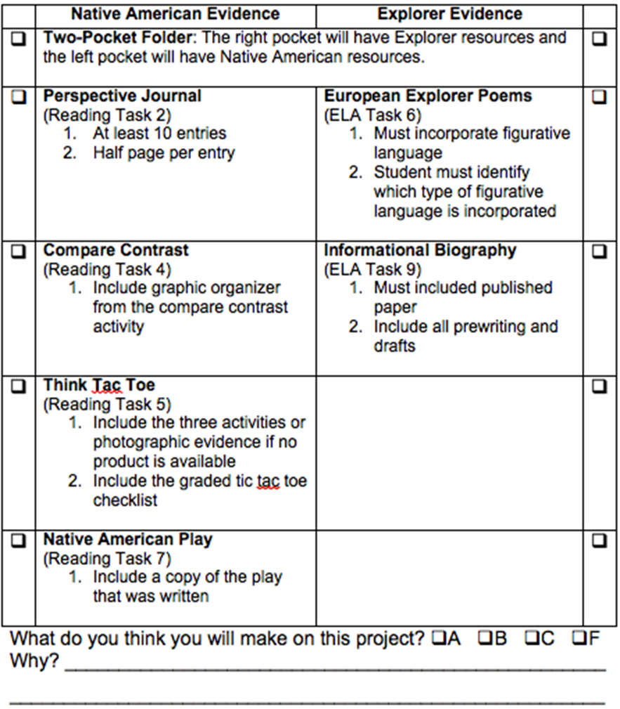

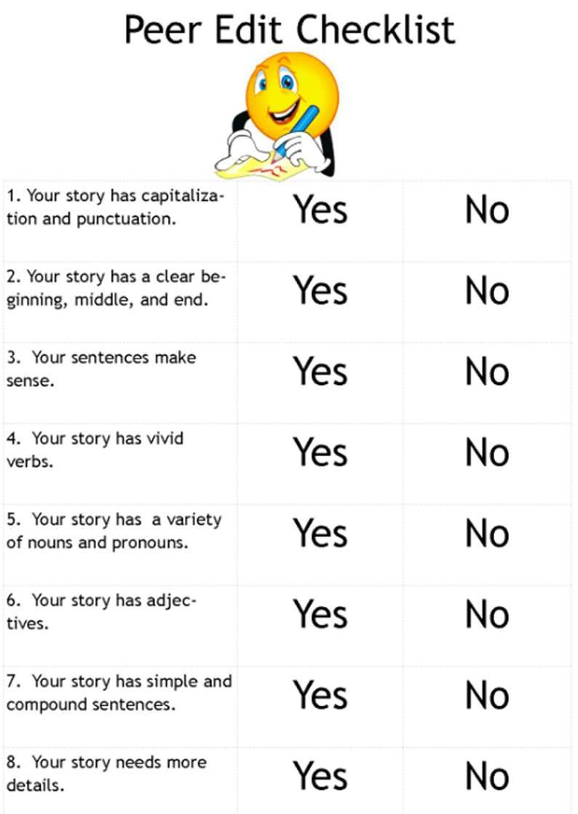

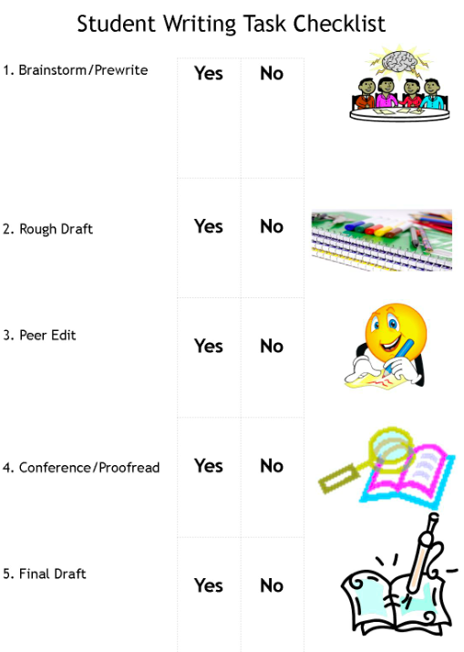

**Biography Editing Practice**

**Introduction**

Imagine you were a passenger on Christopher Columbus’s ship. You leave on August 3, 1492 and don’t see land again until October 12, 1942! That’s a long time! But it’s exactly what happened on board the Nina, pinta, and Santa Maria. In this biography, you will learn more about the voyage and discovery that changed history, about Columbus’s childhood, and about what happened after his discovery.

**Voyage and Discovery**

He was looking for a quicker route to Asia. Christopher Columbus was the first white man to discover the land we call North america. He sailed from Spain in August of 1492. He believed that the earth was rond when most people still believed that it was flat. Columbus believed that sailing west could lead him to Asia faster than going around africa. His crew was very scared. he did not find Asia, rather, he found two continents and changed history.

**Childhood**

Columbus began his life in Italy. Born in 1451, Columbus was the son of a wool weaver. He was always interested in sailing Surprisingly, when he was a boy, he was on a ship that was attacked by pirates. He had to swam to shore. But that did not stop him. Finally, he became a true sailor in 1492 when the King and Queen of Spain paid for his voyage.

Using the proofreading checklist to fix:

-1 indentation error

-4 capitalization errors

-2 spelling errors

-1 fact error

-Move one sentence to a better location

-1 punctuation mark missing

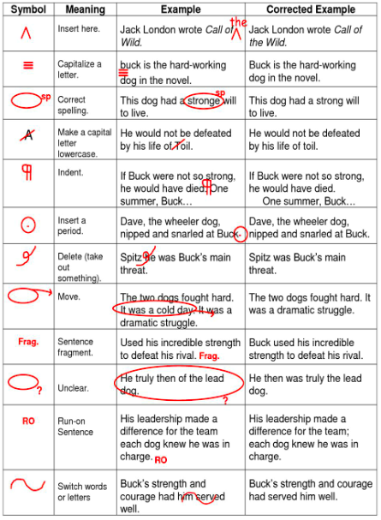

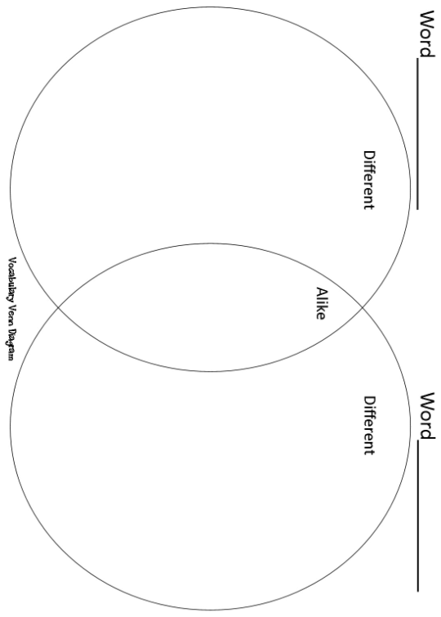

**Vocabulary Cards**

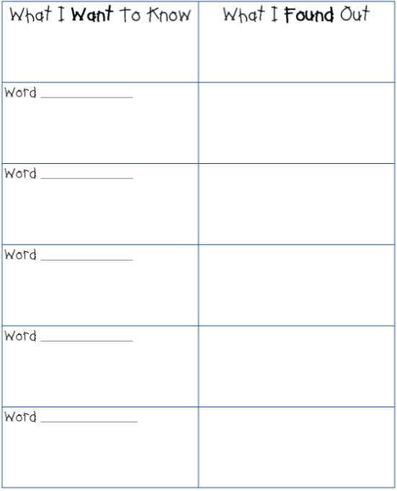

**Sensory Details Vocabulary Description**

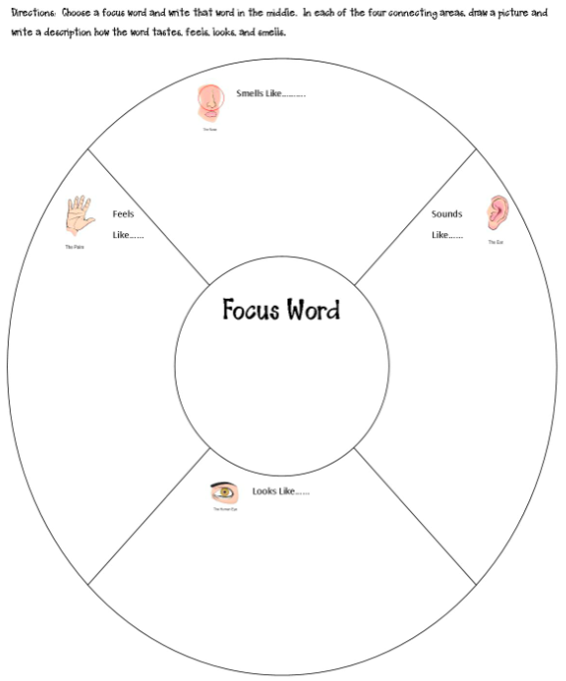

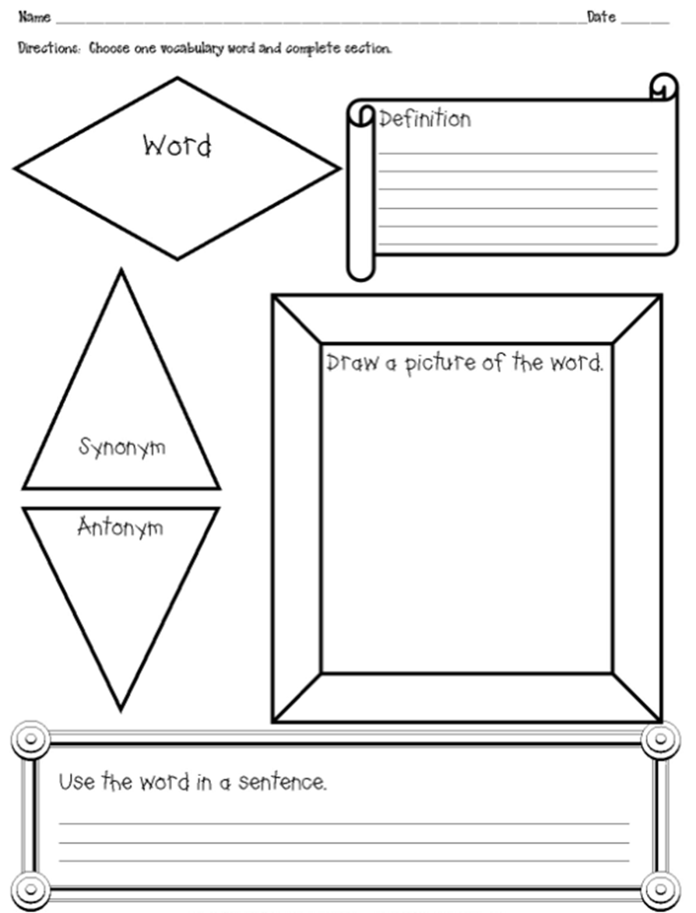

***Sign of the Beaver* & Native American Think-Tac-Toe**

|  |  |  |
| --- | --- | --- |
| 1. Create a **collage** showing the culture from your tribe.  Include cultural elements from #5.          (*Visual/Spatial)* | 2. Learn a Native American **dance** and present it to the class. Give a short **oral report** about the history of the dance.        (*Bodily/Kinesthetic)* | 3. Make a **soap carving** about a character in the book. These are inexpensive materials and soft enough so there is little danger from the tools used for carving. Present carving to the class.    *(Visual/Spatial)* |
| 4. Create a **map** of your tribe’s region/habitat. Include as much detail as possible. Incorporate a legend and symbols.      *(Interpersonal)* | 5. **Research** a Native American tribe. Give an **oral presentation** of your findings. Include habitat, food, clothing, shelter, art/music, etc.    *(Verbal/Linguistic)* | 6. **Dramatize** a scene from the text. If desired, use props and costumes. If the students know the story, improvise the scripts.      *(Verbal/Linguistic)* |
| 7. Create a **diorama** of your Native American tribe’s habitat. Include housing and habitat characteristics.          *(Visual/Spatial)* | 8. Students should make a **crossword puzzle** using at least 20 words related to the text. They must write their own clues.        *(Bodily/Kinesthetic)* | 9. Make a **time line** showing the progression of events in the text.            *(Logical/Mathematical)* |

Directions: Choose any three boxes in a straight line that go through the center. Complete the activities in the three boxes. Presentations will be made in class on _____.

**I choose activities # _____, # _____, #_____.**

***Sign of the Beaver* & Native American Think-Tac-Toe Checklist**

|  |  |  |
| --- | --- | --- |
| 1.  ___ Accurate cultural representation  ___At least 11 x 17 paper  ___Clear format        Bonus: Make it 3-D  *Possible Points = 25* | 2.  ___ Accurate cultural representation  ___ Correct grammar in oral presentation  ___Correct information presented    Bonus: Learn 3 dances  *Possible Points = 25* | 3.  ___ Accurate cultural representation  ___Tell the class in an oral presentation about why this carving was chosen.      Bonus: Include animals  *Possible Points = 25* |
| 4.  ___Includes a legend or key  ___Uses appropriate symbols  ___Clear format  ___ Accurate cultural representation    Bonus: Make the map large  *Possible Points = 25* | 5.  ___habitat ___food  ___clothing ___shelter ___art/music          *Possible Points = 50* | 6.  ___ Script provided  ___ Clear voice  ___ Scene selection is relevant      Bonus: Include costumes  *Possible Points = 25* |
| 7.  ___ Correct grammar, spelling, punctuation.  ___ Point of view/feelings shown  ___ Accurate cultural representation    Bonus: Make an authentic looking journal  *Possible Points = 25* | 8.  ___Includes 20 words  ___ Student written clues  ___Clear Format        Bonus: Make a word find using the same words  *Possible Points = 25* | 9.  ___Shows at least 8 events  ___Correct spelling & grammar  ___Clear format        Bonus: Include additional events from the time period  *Possible Points = 25* |

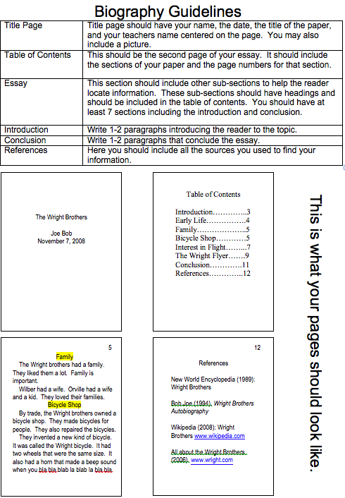

*Grade 4 Resource L*

**ELACC4W2: Write informative/explanatory texts to examine a topic and convey ideas and information clearly.**

|  |  |  |  |  |  |
| --- | --- | --- | --- | --- | --- |
| **Element** | **Does Not Meet** | **Approaches Standard** | **Meets Standard** | **Exceeds Standard** | **Points/**  **Comments** |
| **a. Introduce a topic clearly and group related information in paragraphs and sections; include formatting (e.g., headings), illustrations, and multimedia.** | Writing contains incomplete paragraphs            Point Range  0-9 | Writing contains 1-3 complete paragraphs            Point Range  10-39 | Writing contains 4+ complete paragraphs and a clear introductory statement        Point Range  40 | Writing contains 4+ complete paragraphs with headings and illustrations.        Point Range  42 |  |
| **b. Develop the topic with facts, definitions, concrete details, quotations, or other information and examples related to the topic.** | Attempts to use one: Facts, definitions, concrete details, quotations, or examples  Point Range  0-4 | Attempts to use two: Facts, definitions, concrete details, quotations, or examples  Point Range  5-19 | Uses two correctly: Facts, definitions, concrete details, quotations, or examples  Point Range  20 | Uses three+ correctly: Facts, definitions, concrete details, quotations, or examples  Point Range  22 |  |
| **c. Link ideas within categories of information using words and phrases.** | No transition words      Point Range  0-4 | 1-2 transition words      Point Range  5-9 | 3-4 transition words      Point Range  10 | 5+ transition words      Point Range  12 |  |
| **d. Use precise language and domain-specific vocabulary to inform about or explain the topic.** | No vocabulary words evident      Point Range  0-4 | 1-2 vocabulary words evident      Point Range  5-9 | 3-4 vocabulary words evident      Point Range  10 | 5+ vocabulary words evident      Point Range  12 |  |
| **e. Provide a concluding statement or section related to the information or explanation presented.** | No closure        Point Range  0-4 | Complete closing sentence contained in last paragraph      Point Range  5-19 | Complete closing paragraph      Point Range  20 | Complete closing paragraph that summarizes main ideas of writing    Point Range  22 |  |
| Total Points |  |  |  |  | /100 |

**Alternate Activities**

Research states that elementary students engage more in learning when they have ownership of their learning choices (Patall, Cooper, & Robinson, 2008). Therefore, here are some suggestions for alternative activities that match or correlate with the unit:

* Invent a board game to show the setting of a favorite book. Cards could include questions about the story.
* Make a two-sided diorama by cutting two circles and folding them in half. Then glue the vertical halves of the circles back to back. Students can compare two stories or tell about book characters on the diorama. They can also make a triarama or quadrarama.
* Students can decorate a paper plate like a favorite book character. They can make bodies, arms, and legs with colored paper. On the back, they can write sentences or adjectives telling about their character.
* Use file folders to make a picture book, biography, or book map.
* Cover the triangular part of a wire hanger with construction paper. Students illustrate a favorite book on one side of the paper, then write about the setting, plot, and sequence on the back. The characters can dangle from the hanger.
* Students can write an ad about a favorite book by creating a light switch cover (telling others why they should read the book).
* Make a “sequence” necklace with string, beads or macaroni, and small squares on which students write about the main ideas or characters in a story.
* Make a placemat showing a scene from a book. Decorate the border with names, faces, and descriptions of the main characters in a story.
* Make an accordion book by folding paper in half lengthwise and folding into equal segments. Write about, illustrate, and sequence important events in a book or describe and draw book characters. Students can also make a pop-up book by cutting two slits an inch apart on the fold of a folded piece of construction paper. They push the tab to the inside and draw, color, and cut out a figure from a book or write attributes about the book character and glue to the tab.
* Create an ad, bookmark, award, bumper sticker, door hanger, stamp, or poster for a favorite book or book character to encourage others to read the book.
* Make a belt out of a sentence strip or a piece of poster board. Use the belt to show the sequence or characters of a story. Punch holes in the ends and tie with yarn for students to wear.
* Students write and act out a scene from a book or story.
* Make a plot chart or step book showing characters, setting, problem, events, and ending of a story.
* Use a shoebox to: 1. Make a diorama from a favorite book; 2. Decorate as a book cover and write facts about a book; 3. Make a peek box by cutting a hole in the lid. Color and cut out objects for the scene from the book and glue to the bottom of the shoebox. Write a paragraph about the scene and put on the lid of the box; 4. Cut a window in the bottom of the shoebox and slits on the sides. Draw scenes from the book on paper strips and slide through slits to show a filmstrip of the book.
* Create a board game to show travel through a Native American region.
* Tell about a Native American or explorer’s journey or story using pictographs.
* Students can create an “I am” card by writing facts about themselves or a book or historical character on a 9” X 6” piece of construction paper. They can then hole-punch and hang the card around their neck and answer questions about themselves or the character.
* Make a mural to show an explorer’s journey or Native American region.
* Make a paper doll of a character in a book, an explorer or Native American (writing a paragraph about that person or group).
* Make a passport out of 6” X 9” construction paper. Staple paper inside for pages. Inside, students can describe a Native American tribe, including pages for the group’s name, housing, diet, clothing, and other attributes.
* Make a shopping list from a period in history or for a geographical expedition.
* Make a timeline of events in a student’s or historical figure’s life on adding machine tape or sentence strips.
* Fold a piece of paper into thirds to create a travel guide for a to symbolize a historical figure or event.
* Students choose characters from history and write and act out famous historical scenes.
* Design a flag or postage stamp for a Native American tribe. On the back write facts about the tribe.
* You can also make a foldable book. Fold paper into thirds. Use the three sections to compare two people, places, or things. List their similarities in the center section.

**Graphic Organizers**

[*http://www.eduplace.com/graphicorganizer/*](http://www.eduplace.com/graphicorganizer/)

[*http://www.sanchezclass.com/reading-graphic-organizers.htm*](http://www.sanchezclass.com/reading-graphic-organizers.htm)

[*http://www.enchantedlearning.com/graphicorganizers/*](http://www.enchantedlearning.com/graphicorganizers/)

[*http://www.thinkport.org/technology/template.tp*](http://www.thinkport.org/technology/template.tp)

[*http://www.citrus.k12.fl.us/staffdev/Graphic%20Organizers.htm*](http://www.citrus.k12.fl.us/staffdev/Graphic%20Organizers.htm)

[*http://www.educatorstechnology.com/2012/02/list-of-free-graphic-organizers-for.html*](http://www.educatorstechnology.com/2012/02/list-of-free-graphic-organizers-for.html)

**ESOL Resources**

[*http://www.usingenglish.com/teachers/*](http://www.usingenglish.com/teachers/)

[*http://esl.about.com/u/sty/writinglessonplans/user_writing_lessons/*](http://esl.about.com/u/sty/writinglessonplans/user_writing_lessons/)

[*http://www.bay.k12.fl.us/StudentServices/ESOL/ESOLResources/tabid/543/Default.aspx*](http://www.bay.k12.fl.us/StudentServices/ESOL/ESOLResources/tabid/543/Default.aspx)

[*http://www.englishpond.com/*](http://www.englishpond.com/)

[*http://www.doe.k12.ga.us/Curriculum-Instruction-and-Assessment/Curriculum-and-Instruction/Pages/ESOL-Resources.aspx*](http://www.doe.k12.ga.us/Curriculum-Instruction-and-Assessment/Curriculum-and-Instruction/Pages/ESOL-Resources.aspx)

**Gifted Resource**

[*http://www.gagc.org/resources.asp*](http://www.google.com/url?q=http%3A%2F%2Fwww.gagc.org%2Fresources.asp&sa=D&sntz=1&usg=AFQjCNETEvypjGY5lXKDwDZNGAbKIlYUJg)

[*http://www.giftedstudy.org/resources/*](http://www.giftedstudy.org/resources/)

[*https://www.georgiastandards.org/resources/Pages/Tools/GiftedEd.aspx*](https://www.georgiastandards.org/resources/Pages/Tools/GiftedEd.aspx)

**RTI Resources**

|  |  |
| --- | --- |
| Writing/ Oral Language | Reading Comprehension |
| * Look at a photograph and illustration and give an oral description * Use a scribe to record a language experience dictated by a student * Associate written words what displayed picture symbols * Begin a story with an oral sentence. A student adds another sentence to story. This process continues back and forth until the teacher chooses to bring closure to the story. * Instruct students to point to an object in the room, name the object, and give an oral description of the object. * Display pictures with the words written below. Have students orally form a sentence using the pictures. * Use a story web organizer (i.e., who, where, when, problem, solution) to assist students in brainstorming a narrative story. Students use the completed web as a guide to tell the story aloud. | * Access prior knowledge by discussing a book or selection before reading. * Guide students to make real-life connections with reading materials. * Have students read passage questions prior to reading the passage. * Construct a mini book to retell a story. * Create a character map to describe the main character in the story. * Compare characters in a story or two versions of the same story using a Venn Diagram. * Retell a story by acting it out. * Ask students to write short summaries after reading a selection or passage. * Use advanced, graphic, and semantic organizers as aides. * Teach students to create mental images as they read. The teacher models “thinking out loud” as a story is read orally. Students read a passage and discuss the mental images they created. * Use graphic organizers to develop visual connections for comprehension skills. * Instruct students to read the first sentence of a selection. Teacher models how to ask question about the sentence to build meaning. Continue the process, sentence by sentence, with students asking questions. |

**Suggested Writing Prompts**

**Narrative**

* As you wake up, you realize that today is going to be different. You look in the mirror and see that you are 20 years older. Write a story about what happens the day you wake up 20 years older.
* Choose a time when you did something that took a lot of nerve, a time when you didn't follow the crowd or a time when you stood up for your beliefs. Perhaps your friends were urging you to do something that you were uncomfortable with and you chose not to cave into peer pressure. Maybe you took a stance on a political issue that was important in your community, or you might have Whatever you choose, think about the details of the event and write a story that tells about what happened. Your narrative should show your readers why you decided to make a stand or try something that took nerve, give specifics on the events, and share how you felt after the event.

**Opinion**

* Some students want to have drink and snack machines at your school. Many parents, however, think those foods are not healthy for students. What do you think about having drink and snack machines in school? Write a letter to convince the principal that drink and snack machines should or should not be allowed at your school.
* Some people say that life in the past was better than today. For example, many things cost less in the past. However, other people are glad they live in today’s world with computers and cell phones. Would you rather live in the past or the present? Write a speech to read to your class that tells why you would rather live in the past or in the present.

**Informational**

* Everyone is good at something. It could be a subject in school, a sport, a game, or something you do at home. Think about one thing that you know how to do well. Write a report to your class that describes what you do well and explains how you learned about it.
* You have been chosen to plan a field trip for your class. Think about one place that your class would like to visit. Where would you go and what would you do while you were there? In a letter to be read to your class, describe the field trip you have planned.

**\*Response to Literature**

* Explain how, at the end of the story, Matt had become more like Attean while Attean had adopted very little, if any, of Matt’s ways. How was this situation ironic? Was this the original intent when Saknis made his treaty with Matt? Use specific evidence from the text to support your answer. *Specific to *Sign of the Beaver*

